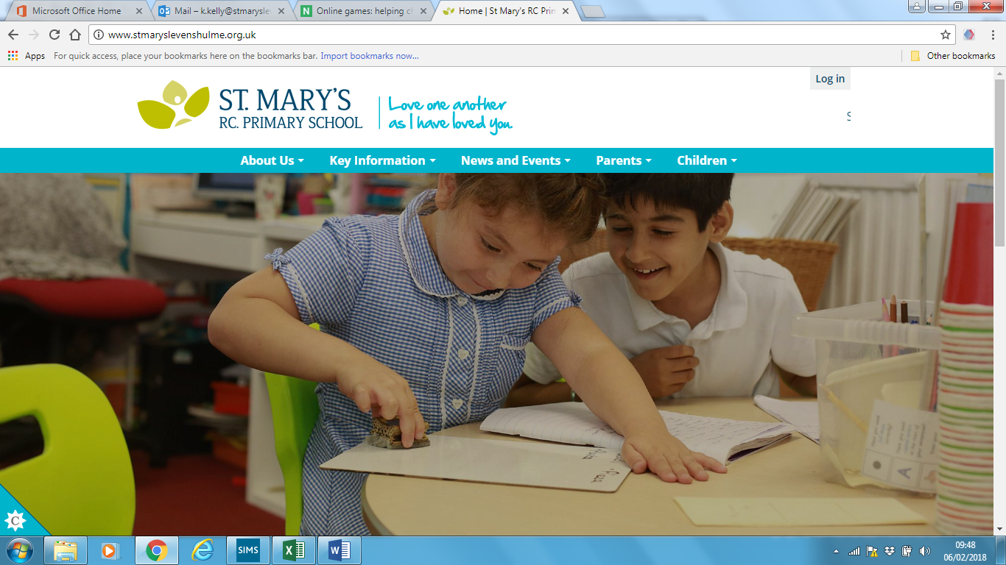

E-Safety Information Pack for Parents and Carers

Produced by St Mary’s RC Primary School Digital Leaders

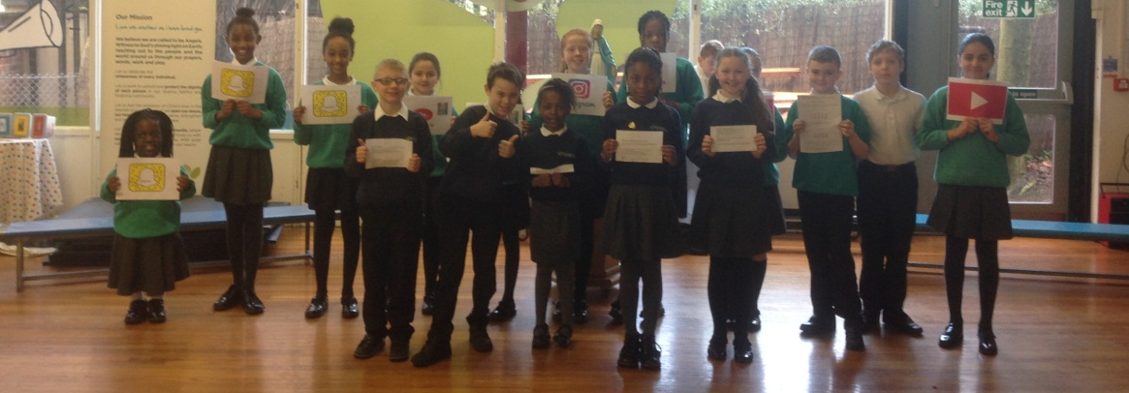

‘Create, Connect and share respect: A better internet starts with you’

Dear Parents/carers,
This week your child has been exploring ways of staying safe while on the internet and how we should conduct ourselves while on line.
We have completed and analysed an e-safety questionnaire that was produced by the Digital Leaders in school – this has helped us to formulate the kind of activities that we would focus on this week to make it relevant for the children of St Mary’s.

EYFS & KS1 have been exploring the theme of making positive connections.
KS2: Year 3 and 4 have been producing class flow charts of the actions they can take if someone was unkind or if they see something that upsets them online –
Year 5 Have been exploring how to use Social Media positively and safely – they have presented their ideas on a Do’s and Don’ts posters.
Year 6 Focus: Dangers of Social Media – Communicating with strangers. Focusing in on the list of social media sites that St Mary’s Children are using.
In this pack you will find the results of our KS2 survey that you might find interesting and other useful information. (Although the survey results show how the KS2 children use the internet and computers, we feel this information is relevant for the parents in EYFS and KS1 also).
If any of you would like to gain a greater understanding of how to keep your children safe while on the internet, please contact the office to secure your place at the NCPCC E-Safety workshop that we are hosting in school on Thursday 22nd March between 2-3pm (there are limited number of places).

Useful Links:
www.thinkuknow.co.uk/
www.thinkuknow.co.uk/professionals/resources/WhoIsSam/
www.thinkuknow.co.uk/11_13/Need-advice/Digital-footprint/
www.internetmatters.org/
View Childnet’s cyberbullying video for KS2 here:
www.childnet.com/resources/the-adventures-of-kara-winston-and-the-smart-crew/chapter4

View Childnet’s Hot Topic on cyberbullying here:
http://www.childnet.com/teachers-and-professionals/for-working-with-young-people/hottopics/cyberbullying

This was an anonymous survey carried out by the Digital Leaders – The children were asked to be as honest as they could be to ensure that the results reflected an accurate picture of how children are using technology at home.

- The results show that the vast majority of children in KS2 who access apps or games at home do so under the supervision of their parents.
- Worryingly a small proportion of children in KS2 are accessing apps or games without their parental supervision.

- The results show a predictable pattern – as children get older the number of them accessing social networking sites increases.
- The numbers of children accessing social networking sites jumps significantly between year 4 and 5.
- Just over a third of year 3 and 4 children access social networking sites, putting them in the minority for lower KS2.
- 85% of year 6 children are using social networking sites.
- Overall, the majority of KS2 children do access social networks.

- Not surprisingly, as the children are getting older and using more social networking sites, they are communicating more frequently with strangers on line, therefore, putting themselves at greater risk and making themselves more vulnerable.

- In correlation to children accessing more social networking sites as they get older, the likelihood of your child receiving insulting or upsetting messages on line increases as they get older, exactly 46% of year 5 and 6 pupils have been subjected to these kind of messages while accessing social networks at home.

- The results show that the majority of St Mary’s children who use social networks do so responsibly.

- The results show that Snapchat, Instagram, Musical.ly and YouTube are the most popular social Network sites of the St Mary’s children.
- The favourites for the children in lower KS2 who are accessing social networking sites are Roblox and YouTube.

- The results show that children across KS2 are accessing inappropriate gaming material for their age.
- More children in upper KS2 are accessing these games.
- Overall, in KS2, a minority of 40% of children are accessing inappropriate games for their age, in comparison the majority of 60% of children who don’t.
(So when your child says that everyone else is playing these games, you can tell them that they are wrong!)

- The results show that a (frighteningly) vast array of inappropriate games are being accessed by the minority of children who do play these games in KS2.
- Worryingly the two most popular games contain the most violent and adult content; children from year 3 upwards have admitted playing these games.
(Please note: because of the advice that we receive from Manchester Children Services, we are duty bound to report the use of age inappropriate games by children as a safeguarding matter and to record it as an e-safety incident)

- The results show that the majority of children know not to share personal information on line.
- Year 5 children are most likely to share personal information on line.
We hope that you have found this information useful and that it gives you a better insight into how children at St Mary’s are using computers. We will continue to promote e-safety in school and we appreciate your continued support on this matter.


