
Year Group: EYFS Curriculum Overview 2020-2021 (Nursery to follow ITM planning see LTP)
 | Autumn 1 | Autumn 2 | Spring 1 | Spring 2 | Summer 1 | Summer 2
Growth Mindset | Show co-operation | Stay curious | Make it better | Be resilient | Challenge yourself | Always be creative
Topic: | All About Me! | Changes | Dinosaurs and the Environment | Space – Let’s Blast Off! | Growth | Superheroes
PSHE Focus | Eat Healthy |  | Stay Safe |  | Keep Fit
Real life experience | Favourite Toy Day | Autumn walk – local Park | food tasting – Chinese New Year | Wonder Dome | Trip to local shops  Chicks/ Caterpillars | Local hero visit (police/ fire/ ambulance etc.)  Super hero day
Events and Celebrations | Yom Kippur | All Saints  Bonfire Night  Diwali  St Andrews  Remembrance Day Advent  Christmas | Chinese New Year  St Patrick’s Day  St David’s Day | Lent  Mothers’ Day  Easter  St George’s Day  Bonnet Parade | Pentecost | Transition to Year 1
Religious Education | Myself  Welcome | Birthday  Other faiths | Celebrating  Gathering | Growing  Lenten Reflections | Good News/ Friends  Other faiths | Our World
English | The Tiger Who Came to Tea / Monkey and Me  Labels, captions, recounts  My favourite toy descriptions  Tales Toolkit narratives | Lists  Captions  Simple retell  Advent/Nativity  Cards  Tales Toolkit narratives | Letters  Non-fiction texts – dinosaurs/ environment- materials  Instructions – How to take care of our world  Posters  Description – setting, characters  Tales Toolkit narratives | Story writing – innovation  Non-fiction space  Maps – labels/ instructions  Tales Toolkit narratives | Story writing  Real life narratives – chicks/ caterpillars  Instructions – fruit salad/ planting a seed etc.  Non-fiction books  innovation  Factfile | Non-fiction – real heroes  Innovation – becoming their own superhero  Captions for photos – visit from fire crew
Maths  Following WRM | Baseline (3 weeks)  Numbers (counting and recognition) (3 weeks) | SSM- 2D shapes (2 weeks)  SSM – Time (1 week)  Numbers (addition and subtraction) (3 weeks) | Numbers (counting and recognition) (3 weeks)  SSM – size, weight and capacity (3 weeks) | Numbers (addition and subtraction) (3 weeks)  SSM – 3D shape (2 weeks)  SSM - Money | Numbers (counting and recognition) (2 weeks)  Numbers (addition and subtraction) (2 weeks)  Numbers (doubling, halving and sharing) (2 weeks) | Numbers (doubling, halving and sharing) (1 weeks)  SSM – position and distance (3 weeks)  Recap – consolidation.
Expressive Arts | Painting: self-portraits.  Models of favourite toys  Music/ dance - emotions | Chalk/charcoal drawings.  Printing (pattern)  Colour mixing  Christmas crafts-shape, assemble, join  Changes in music – loud/ quiet/ quick and slow | Collage  Texture focus  Junk modelling  Dancing like dinosaurs (The Planets Gustav Holst)/ Carnival of the animals – matching pieces to habitats and animals/ junk instruments | papier mache plants  Large scale model making – whatever next vehicles  paper boats (The Marvellous Moon Map) | Observational drawings.  Animal masks  moving like different animals | Hero/ villain masks – costumes/ capes  Creating backdrops for small world – s=cityscapes  Superhero/villain music
Understanding the World | Changes in life baby- child – adult  family customs- Home corner  Their unique qualities – sims and differences  Computing – introduce Purple Mash | changes – seasonal/ passage of time  decay  celebrations  Computing – changing an image (simple paint programme) | Caring for our environment and living things.  Materials  sorting – patterns | Solar system  Our planet – habitats  Shadows  Maps  floating and sinking  Computing – Google Earth | Caring for our environment and living things.  Planting and growing/ life cycles  patters and change  Observations  Making bread/ fruit salad/kebabs | Similarities and differences  Occupations  Computing – Beebot/ programmable toy
Text / film Focus | 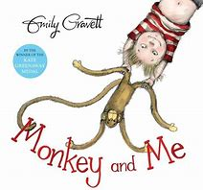 | 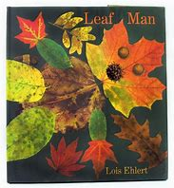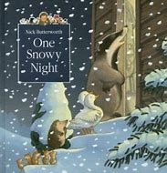  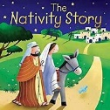 | 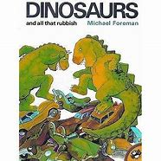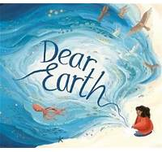 | 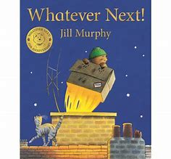 | 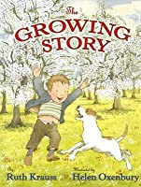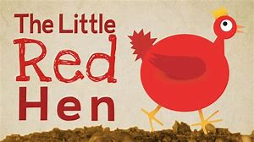 | 

