
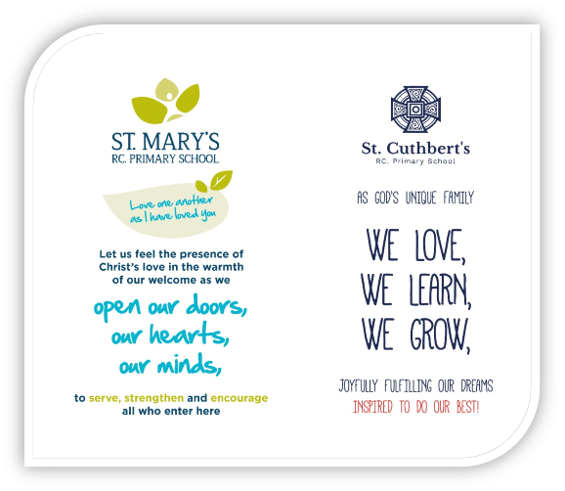
2023/2024

Success in Science




Subject audit
, Subject audit
Date | A | S | S
Quality of Education
Intent | O
Does your subject reflect a coherent rationale for the school’s broad and balanced curriculum? | O
Is there a carefully sequenced progression of Science knowledge/concepts/skills to end of KS1/2 | O
Does your unique Science curriculum meet your pupils’ needs & meet N.C standards? | O
Curriculum coverage allows all pupils to access content & make progress | O
Clear identified targets are shown through the Curriculum Development plan | O
Implementation
Teachers can explain what children learn/why it’s important in your subject’s curriculum | O
Subject leader’s review / quality assure LTP and Unit Plans and check against in book looks to ensure implantation of intent | O
Teachers understand what the depth of knowledge expected is at the end of every unit / year through knowledge organisers | O
Subject leaders show knowledge and expertise to design, support and deliver the curriculum through the development of knowledge organisers and support given to teachers | O
Book looks, working walls, pupil voice and school trips, show that your subjects’ curriculum is implemented fully | G
Teachers organise and sequence learning appropriately – shown in unit plans and LTPs | O
There are opportunities for CPD support to upskill teachers in knowledge and skills for your subject | O
Subject leaders, teachers and pupils are clear on how units are assessed and how progress is shown | G
Differentiation is appropriate to enhance all pupils’ capacity to access the full curriculum | O
Use of the locality are maximized to provide firsthand experience within your subject. | G
Pupils use appropriate resources for your subject to build knowledge and skills | O
Clear understanding of what progression looks like in and across each year group – progression of vocabulary is explicit | O
Opportunities for all staff to moderate/ share / feedback on work | G
Impact
Pupils have embedded and retained fluent knowledge in your subject’s knowledge, skills and vocabulary (in and across years) | G
Children have progressed in different strands of your subject and this is clear from book look and pupil voice | O
Subject Portfolio shows children voice, learning and progress through examples of work, images etc | O
Behaviours and Attitudes
Pupil voice shows learners are positive towards your subject | O
All groups are committed to learning, know how to learn and take pride in the work for your subject | O
Personal Development
Builds knowledge, skills and critical thinking that helps prepare for next stage | O
Provides opportunities to help learners discover wider interests | O
Supports learners to develop their character through a Growth Mindset | O
Prepares learners to be responsible and active citizens | O
Supports the development of an understanding of British values and appreciate commonality and diversity | O
Leadership and Management | O
Subject leader is effective and has an ambitious vision to provide a high quality and inclusive subject curriculum | O
Subject leader provides opportunities and focus on improving staff subject and content knowledge | O
Practice and knowledge of staff is building over time | O
Assessment is used appropriately to help support all pupils to make progress and achieve | G

Why is Science important at our school?
A high-quality science provides the foundations for understanding of the world through the specific disciplines of biology, chemistry and physics underpinned through Working Scientifically.
Science has changed our lives and is vital to the world’s prosperity and all pupils should be taught the essential aspects of knowledge, methods and processes and uses of Science. Through the building up of a body of key foundational knowledge and concepts, pupils should be encouraged to recognise the power of rational explanation and develop a sense of excitement and curiosity about natural phenomena.
Science Intent:
Science teaching at St. Mary’s R.C. Primary School aims to give all children a strong understanding of the world around them whilst acquiring specific skills and knowledge to help them to think scientifically, to gain an understanding of scientific processes and also an understanding of the uses and implications of Science, today and for the future.
A high-quality science education provides the foundations for understanding the world through the specific disciplines of biology, chemistry and physics. Science has changed our lives and is vital to the world’s future prosperity, and all pupils should be taught essential aspects of the knowledge, methods, processes and uses of science. Through building up a body of key foundational knowledge and concepts, pupils should be encouraged to recognise the power of rational explanation and develop a sense of excitement and curiosity about natural phenomena.
At St. Mary’s R.C. Primary School, scientific enquiry skills are embedded in each topic the children study and these topics are revisited and developed throughout their time at school. Topics are taught in Key Stage One and studied again in further detail throughout Key Stage Two in more depth, with an increasing complexity of language and precision being expected. This model allows children to build upon their prior knowledge and increases their enthusiasm for the topics whilst embedding this procedural knowledge into the long-term memory. Pre and post diagnostic assessments are used to ensure that staff and pupils are aware of their achievements. Through our carefully designed curriculum, children gain skills to enable them to become life-long learners.
All children are encouraged to develop and use a range of skills including observations, planning and investigations, as well as being encouraged to question the world around them and become independent learners in exploring possible answers for their scientific based questions. Specialist vocabulary for topics is taught and built up, and effective questioning to communicate ideas is encouraged. Concepts taught should be reinforced by focusing on the key features of scientific enquiry, so that pupils learn to use a variety of approaches to answer relevant scientific questions. We provide our children with wider opportunities in science and make links to other subjects. Teachers plan and challenge pupils based on the whole school progression document for working scientifically and subject fluency, to ensure knowledge and skills are built upon, unique to our school and our needs. We monitor our school’s progress in Science in line with our school assessment policy.

Purpose of study
A high-quality science education provides the foundations for understanding the world through the specific disciplines of biology, chemistry and physics. Science has changed our lives and is vital to the world’s future prosperity, and all pupils should be taught essential aspects of the knowledge, methods, processes and uses of science.
Through building up a body of key foundational knowledge and concepts, pupils should be encouraged to recognise the power of rational explanation and develop a sense of excitement and curiosity about natural phenomena. They should be encouraged to understand how science can be used to explain what is occurring, predict how things will behave, and analyse causes.
Aims of the Science National Curriculum:
• Develop scientific knowledge and conceptual understanding through the specific disciplines of biology, chemistry and physics
• Develop understanding of the nature, processes and methods of science through different types of science enquiries that help them to answer scientific questions about the world around them
. • Are equipped with the scientific knowledge required to understand the uses and implications of science, today and for the future.
Implementation
• We maintain a high level of subject knowledge of science in our school by regular training and professional development
• Regular and rigorous monitoring ensures that coaching and mentoring of staff is specifically targeted to ensure that staff are appropriately supported to development needs
• Rigorous monitoring ensures that the subject leader has a focused approach towards development of the subject within the school according to the needs of the pupils to ensure progress. The monitoring cycle ensures that Science contributes to the school improvement plan
• Teachers use assessment for and of learning to ensure that teaching is planned to ensure that learning is and consolidated and plans for next steps. Children are provided with regular opportunities to develop strategies for questioning and thinking. Regular monitoring shows that our children understand and apply key scientific principles within their work
• Teachers use knowledge organisers and effective teaching of Science, Science specific vocabulary, knowledge and working scientifically skills are developed through each topic
• With effective subject management, we are a well-equipped and resourced school
Impact
• Children enjoy and are enthusiastic about science in our school
• There is a clear progression of children’s work and teachers’ expectations in our school
• Children’s work shows a range of topics and evidence of the curriculum coverage for all science topics
• Children are becoming increasingly independent in science, selecting their own tools and materials,
completing pupil lead investigations and choosing their own strategies for recording
• Feedback from teachers has impact on our pupils, often with challenge and next step questions to push learning on
• Standards in science at the end of the key stages are good and issues arising are addressed effectively in school
• Teachers’ judgements are moderated internally and externally at Science cluster meetings
• Our SLT and governors are kept up to date with developments in Science with subject position statements, action plans and review meeting

Science Rationale
Children are naturally curious. Science at primary school should nurture this curiosity and allow them to ask questions and develop the skills they need to answer those questions.
At St Mary’s RC Primary School, our carefully designed Science curriculum helps pupils to:
● investigate problems through exploring the five scientific areas of enquiry ● learn how science works
● discover why science matters in the world.
To enable this, time, expertise and resources are built into our whole school curriculum to enable the delivery of engaging and thought-provoking science lessons.
EYFS:
Science is delivered under the umbrella of, ‘Understanding our World,’ through continuous provision activities. The Science curriculum is designed to give pupils opportunities to begin to develop scientific questioning, knowledge and skills. The EYFS curriculum directly links to the Year 1 Science curriculum.
Key stage 1
Science is primarily delivered in discreet afternoon sessions, once a week. Staff follow the Science whole school overview and the 2014 National Curriculum learning objectives to plan lessons which embed knowledge whilst integrating working scientifically skills. This knowledge and skills are built upon as the year progresses to ensure that pupils experience all areas of enquiry and become fluent in the use of the appropriate vocabulary. Pupils are given the opportunity to experience the five areas of enquiry, using appropriate scientific equipment. The use of prior knowledge is encouraged through the use of knowledge organisers and careful spiralling of learning. Assessment of learning is holistic – taking account of diagnostic and post testing, AFL and teacher assessment. Progress is regularly discussed with staff and targets set regularly for staff and pupils. Data is recorded according to the school policy and the statutory teacher assessment framework is used to make a judgement at the end of the key stage, which is reported to the D.F.E. Year 2 teachers have evidence from the classroom that pupils have reached the age-related expectations for all the ‘working scientifically’ statements and all the ‘science content’ taught in the final year of the key stage. Pupils are given the opportunities to use their scientific understanding and skills in other curricular areas and are given opportunities to use their curricular skills in science. Explicit links are made to CARITAS, CATHOD and Laudato Si. Outdoor learning takes a priority within the Science curriculum, with pupils given as many opportunities to take the learning into real-life contexts. Science Capital is embedded within the schemes of learning to enable pupils to relate their learning to everyday life.
Key stage 2
As in Key stage one, Science in key stage two is primarily delivered in discreet afternoon sessions, once a week. Using the Science whole overview and the 2014 National Curriculum learning objectives, teachers plan creative lessons which build upon the foundation of questioning, thinking, knowledge and skills introduced in EYFS and key stage one. Pupils are encouraged to develop and use their working scientifically skills more independently as they move through the phase – the use of computing becomes more explicit. Pupils are given the opportunity to develop the five areas of enquiry, using appropriate scientific equipment. Assessment is rigorous and routine, feeding into the whole school assessment policy. Teachers consider a range of evidence from the classroom on which to base their teacher assessment judgements. When making a statutory end-of-key stage judgement, teachers use the statutory teacher assessment framework, using data from across the key stage. Year 6 teachers have evidence from the classroom that pupils have reached age related expectations, or beyond, for all the ‘working scientifically’ statements and all the ‘science content’ taught in the final year of the key stage. Pupils are encouraged to take their learning outside regularly, being given opportunities to reflect upon the importance of this. Links to Science learning is evident in other curricular areas, as is the development of cross curricular learning in Science. As in key stage one, explicit links are made to RRS, CARITAS, CATHOD and Laudota Si. Science capital is embedded.
Across all key stages, the sequence of teaching and learning has been carefully planned through discussion with the class teachers and Science co-ordinator. By looking carefully at the Working Scientifically content and Knowledge content, decisions have been made where there can be clear links between the rest of the curriculum and where best to place units to allow for the development of skills and their use of prior knowledge. For example, in year 3 ‘rocks’ is taught in the Autumn term so that skills and knowledge are taught in the Autumn term so that pupils can apply this knowledge in the study of the stone age in the Spring term. In year 6, the teaching of variables is embedded during the unit ‘animals including humans’ ,which links nicely to their work on World War 2 and to the PE studied, so that they become independent in their control of variables in the Spring term when studying light.

What are the key knowledge concepts in Science at St Mary’s?
Working Scientifically | Plants | Animals, including humans
Pattern seeking  Research  Fair testing  Observation over time  Identifying and  classifying | Plants around us  Plants that benefit us  Life cycles  Reproduction  Environnmental changes | Senses  Healthy eating and exercise skeletons, muscles and circulation  Teeth and digestion  Human development
Everyday materials | Living things | Physical world
Labelling Properties  and uses  States of matter | Classifying and sorting  Food chains  Environmental factors  Habitats | Rocks & soils  Light  Forces  Electricity

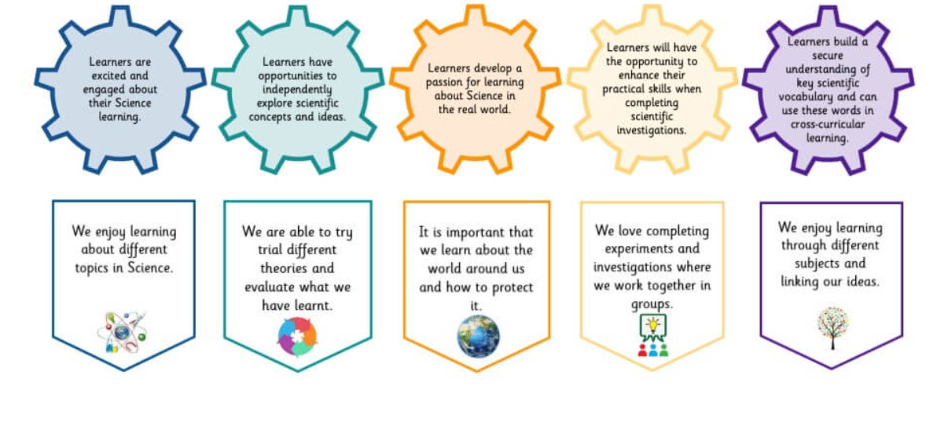

What are the key Science Subject Discipline Skills?
• Being curious and ask questions about what they notice.
• Developing their understanding of scientific ideas
• using different types of scientific enquiry to answer their own questions, • Observing changes over a period of time, noticing patterns, grouping and classifying things, carrying out simple comparative tests, and finding things out using secondary sources of information.
• Using simple scientific language to talk about what they have found out and communicate their ideas to a range of audiences in a variety of ways.
• Using scientific equipment and resources in a safe and knowledgeable way.
• Understanding resilience in Science.
How does St Mary’s ensure progression in our key knowledge and concepts in Science?
    - Knowledge taught becomes more in depth
    - Increasing complexity of language and precision expected
    - Pre and post diagnostic assessments are used at the start of end of each unit to ensure that pupils can assess and reflect on their developing knowledge and understanding
    - Whole school progression document for working scientifically and subject fluency to ensure knowledge and skills are built on
    - Regular reflection of prior knowledge, developing links with new knowledge

How do we know our children have made progress?
We use a range of assessment strategies to ensure that pupils are making good progress at key points in their primary education. Pupils and teachers use assessment for learning strategies to help inform them of their understanding (based on the TAPs model). These assessments are supported by the use of moderated Rising Stars assessments. The findings of these are recorded by staff and pupils and reflected upon to set targets for learning. All of these assessments inform the teachers assessment of learning which is regularly recorded on I-track . This data is analysed by the subject lead, who feeds their conclusions back to staff. Targets are then set which inform teaching and learning.

Substantive knowledge
End points EYFS:
Children at the expected level of development will:
- Explore the natural world around them, making observations and drawing pictures of animals and plants;
- Know some similarities and differences between the natural world around them and contrasting environments, drawing on their experiences and what has been read in class;
- Understand some important processes and changes in the natural world around them, including the seasons and changing states of matter.
At St. Mary’s:
3- to 4-year-olds:
- Begin to understand the need to respect and care for the natural environment and all living things
- Plant seeds and care for growing plants
- Understand the key features of the life cycle of a plant and an animal
- Know that there are different countries in the world and talk about the differences they have experienced or seen in photos
- Use all their senses in hands on exploration of natural material
- Explore collections of materials with similar and /or different properties
- Talk about the differences between materials and changes they notice.
- Explore how things work
- Explore and talk about different forces they can feel.

Reception:
- Explore the natural world around them
- Describe what they see, hear and feel whilst outside
- Recognise some environments that are different to the one in which they live
- Understand the effect of changing seasons on the natural world around them.

End points Year 1
Children can:
● Identify and name a variety of common wild and garden
plants, including deciduous and evergreen tree
● Identify and describe the basic structure of a variety of
common flowering plants, including trees.
● Identify and name a variety of common animals including
fish, amphibians, reptiles, birds and mammals
● Identify and name a variety of common animals that are
carnivores, herbivores and omnivores
● Describe and compare the structure of a variety of
common animals (fish, amphibians, reptiles, birds and
mammals, including pets)
● Identify, name, draw and label the basic parts of the human
body and say which part of the body is associated with each
sense.
● Distinguish between an object and the material from which it is made ● Identify and name a variety of everyday materials, including
wood, plastic, glass, metal, water, and rock
● Describe the simple physical properties of a variety of everyday materials ● Compare and group together a variety of everyday materials on the basis of their simple physical properties.
● observe changes across the four seasons
● observe and describe weather associated with the seasons and how day length varies
At the end of EYFS, we expect the children to have reached the appropriate level in
End points Year 2
Children can
● Explore and compare the differences between things that are living, dead, and things that have never been alive
● Identify that most living things live in habitats to which they are suited and describe how different habitats provide for the basic needs of different kinds of animals and plants, and how they depend on each other
● Identify and name a variety of plants and animals in their habitats, including microhabitats
● Describe how animals obtain their food from plants and other animals, using the idea of a simple food chain, and identify and name different sources of food. ● Observe and describe how seeds and bulbs grow into mature plants ● Find out and describe how plants need water, light and a suitable temperature to grow and stay healthy.
● Notice that animals, including humans, have offspring which grow into adults ● Find out about and describe the basic needs of animals, including humans, for survival (water, food and air)
● Describe the importance for humans of exercise, eating the right amounts of different types of food, and hygiene.
● Identify and compare the suitability of a variety of everyday materials, including wood, metal, plastic, glass, brick, rock, paper and cardboard for particular uses ● Find out how the shapes of solid objects made from some materials can be changed by squashing, bending, twisting and stretching.
End points Year 3
Children can
▪ Recognise that soils are made from rocks and organic matter. ▪ Recognise that they need light in order to see things and that dark is the absence of light
▪ Notice that light is reflected from surfaces
▪ Recognise that light from the sun can be dangerous and that there are ways to protect their eyes
▪ Recognise that shadows are formed when the light from a light source is blocked by an opaque object
▪ Find patterns in the way that the size of shadows change. ▪ Compare how things move on different surfaces
▪ Notice that some forces need contact between two objects, but magnetic forces can act at a distance
▪ Observe how magnets attract or repel each other and attract some materials and not others
▪ Compare and group together a variety of everyday materials on the basis of whether they are attracted to a magnet, and identify some magnetic materials
▪ Describe magnets as having two poles
▪ Predict whether two magnets will attract or repel each other, depending on which poles are facing.
End points Year 4
Children can
● Recognise that living things can be grouped in a variety of ways
● Explore and use classification keys to help group, identify and name a variety of living things in their local and wider environment
● Recognise that environments can change and that this can sometimes pose dangers to living things.
● Describe the simple functions of the basic parts of the digestive system in humans
● Identify the different types of teeth in humans and their simple functions ● Construct and interpret a variety of food chains, identifying producers, predators and prey.
● Compare and group materials together, according to whether they are solids, liquids or gases
● Observe that some materials change state when they are heated or cooled, and measure or research the temperature at which this happens in degrees Celsius (°C)
● Identify the part played by evaporation and condensation in the water cycle and associate the rate of evaporation with temperature. ● Identify how sounds are made, associating some of them with something vibrating Recognise that vibrations from sounds travel through a medium to the ear
▪ Find patterns between the pitch of a sound and features of the object that produced it ▪ Find patterns between the volume of a sound and the strength of the vibrations that produced it
▪ Recognise that sounds get fainter as the distance from the sound source increases. ▪ Identify common appliances that run on electricity
▪ Construct a simple series electrical circuit, identifying and naming its basic parts, including cells, wires, bulbs, switches and buzzers
▪ Identify whether or not a lamp will light in a simple series circuit, based on whether or not the lamp is part of a complete loop with a battery
▪ Recognise that a switch opens and closes a circuit and associate this with whether or not a lamp lights in a simple series circuit
▪ Recognise some common conductors and insulators, and associate metals with being good conductors.
End points Year 5
Children can
▪ Describe the differences in the life cycles of a mammal, an amphibian, an insect and a bird
▪ Describe the life process of reproduction in some plants and animals. ▪ Describe the changes as humans develop to old age.
▪ Compare and group together everyday materials on the basis of their properties, including their hardness, solubility, transparency, conductivity (electrical and thermal), and response to magnets
▪ Know that some materials will dissolve in liquid to form a solution, and describe how to recover a substance from a solution
▪ Use knowledge of solids, liquids and gases to decide how mixtures might be separated, including through filtering, sieving and evaporating
▪ Give reasons, based on evidence from comparative and fair tests, for the particular uses of everyday materials, including metals, wood and plastic ▪ Demonstrate that dissolving, mixing and changes of state are reversible changes
▪ Explain that some changes result in the formation of new materials, and that this kind of change is not usually reversible, including changes associated with burning and the action of acid on bicarbonate of soda.
▪ Describe the movement of the Earth, and other planets, relative to the Sun in the solar system
▪ Describe the movement of the Moon relative to the Earth
▪ Describe the Sun, Earth and Moon as approximately spherical bodies ▪ Use the idea of the Earth’s rotation to explain day and night and the apparent movement of the sun across the sky.
▪ Explain that unsupported objects fall towards the Earth because of the force of gravity acting between the Earth and the falling object
▪ Identify the effects of air resistance, water resistance and friction, that act between moving surfaces
▪ Recognise that some mechanisms, including levers, pulleys and gears, allow a smaller force to have a greater effect.

End points Year 6
Children can
● Describe how living things are classified into broad groups according to common observable characteristics and based on similarities and differences, including microorganisms, plants and animals
● Give reasons for classifying plants and animals based on specific characteristics.
● Identify and name the main parts of the human circulatory system, and describe the functions of the heart, blood vessels and blood
● Recognise the impact of diet, exercise, drugs and lifestyle on the way their bodies function
● Describe the ways in which nutrients and water are transported within animals, including humans.
● Recognise that living things have changed over time and that fossils provide information about living things that inhabited the Earth millions of years ago ● Recognise that living things produce offspring of the same kind, but normally offspring vary and are not identical to their parents
● Identify how animals and plants are adapted to suit their environment in different ways and that adaptation may lead to evolution.
● Recognise that light appears to travel in straight lines
● Use the idea that light travels in straight lines to explain that objects are seen because they give out or reflect light into the eye
● Explain that we see things because light travels from light sources to our eyes or from light sources to objects and then to our eyes
● Use the idea that light travels in straight lines to explain why shadows have the same shape as the objects that cast them.
● Associate the brightness of a lamp or the volume of a buzzer with the number and voltage of cells used in the circuit
● Compare and give reasons for variations in how components function, including the brightness of bulbs, the loudness of buzzers and the on/off position of switches
● Use recognised symbols when representing a simple circuit in a diagram

Working scientifically

At the end of EYFS, we would expect the pupils to be able to:

3 to 4 year olds

- Talk about what they see using a wide vocabulary

Reception
- Ask simple questions
- Observe using simple equipment
- Perform simple tests in class or group settings
- Use ideas and observations to try to answer questions
- Help gather and record data as a class or in a group and discuss finding

- At the end of key stage 1, we would expect the pupils to:

- ask simple questions and recognising that they can be answered in different ways
- observe closely, using simple equipment
- Perform simple tests
- Identify and classify
- use their observations and ideas to suggest answers to questions
- gather and record data to help in answering questions

At the end of lower key stage 2, we expect pupils to be able to:
- Ask relevant questions and use different types of scientific enquiries to answer them
- set up simple practical enquiries, comparative and fair tests
- make systematic and careful observations and, where appropriate, take accurate measurements using standard units, using a range of equipment, including thermometers and data loggers
- gather, record, classify and present data in a variety of ways to help in answering questions
- record findings using simple scientific language, drawings, labelled diagrams, keys, bar charts, and tables
- report on findings from enquiries, including oral and written explanations, displays or presentations of results and conclusions
- use results to draw simple conclusions, make predictions for new values, suggest improvements and raise further questions
- Identify differences, similarities or changes related to simple scientific ideas and processes
- use straightforward scientific evidence to answer questions or to support their findings

At the end of upper key stage 2, we expect pupils to be able to:

- plan different types of scientific enquiries to answer questions, including recognising and controlling variables where necessary
- take measurements, using a range of scientific equipment, with increasing accuracy and precision, taking repeat readings when appropriate
- record data and results of increasing complexity using scientific diagrams and labels, classification keys, tables, scatter graphs, bar and line graphs
- use test results to make predictions to set up further comparative and fair tests
- report and present findings from enquiries, including conclusions, causal relationships and explanations of and a degree of trust in results, in oral and written forms such as displays and other presentations
- identify scientific evidence that has been used to support or refute ideas or arguments

Science Long Term Plans 2023/2024

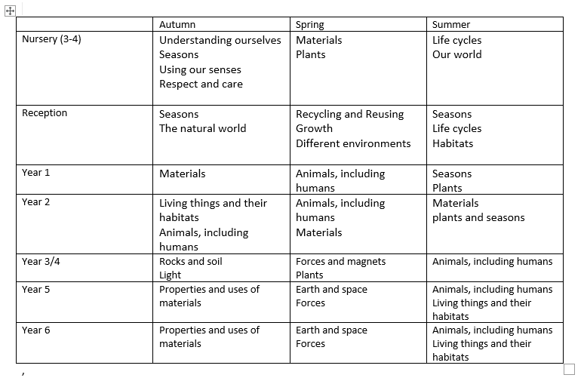How well do children learn in Science at St Mary’s?
How well do they learn? | Evidence
Good knowledge and application | Progress in books  Pupil voice  Assessment data
Application of knowledge and skills  (substantive and disciplinary knowledge) | Progress in books  Pupil voice  Assessment data
Excellent use of scientific vocabulary | Pupils’ books and pupil voice
Application of cross curricular knowledge and skills | Pupils’ books - all subjects and pupil voice
Application of prior knowledge | Assessment, pupils’ books and pupil voice

Subject Overview
Context
Science is a core subject at the St Mary’s and its profile reflects this. Pupils and staff have high expectations of their teaching and learning which has been promoted through strong leadership. Science is taught discreetly, once a week, and all learning is underpinned through Working Scientifically. Science at St Mary’s allows pupils to nurture their learning powers, explicitly staying curious, and allows them to ask questions and develop the skills they need to help answer these questions about the world around them. Through this, we can help them to discover why science matters in the world.
All areas of scientific inquiry and cross curricular links are embedded into the subject across all year groups, teaching and learning is creative and engaging with pupils enjoying this subject which enables them to make good to outstanding progress in all year groups.
Some areas still need developing such as ensuring that newly appointed staff feel confident in their assessment of Science and that all teachers feel more confident in how they teach their pupils writing in Science. Science capital is still in the early stages of being embedded in some year groups.
Over the past year, a higher profile has been given to embracing pupils’ prior learning in Science and teachers have worked hard to develop review systems such as mind maps, working walls and reflection activities to encourage pupils to see the value of sticky knowledge in reducing their cognitive load. Working alongside this, has been the development of reading in Science through the development of Science libraries linked to current learning. There has been a lot of valuable time and energy put into developing the EYFS curriculum and evidencing learning of Science.

Long-Term Priorities (2-3 Year Timescale)
● Sustain high profile of Science in school ensuring that all teachers reflect the same high expectations of teaching, learning and assessment
● Develop robust links with the community and within the locality and that these are embedded to support Science learning and Science capital
- Continued developed of schemes of learning to reflect current thinking
- Continued development of outdoor spaces to ensure that all year groups embrace the learning opportunities they have to offer
- Continue to develop moderation opportunities both within and across schools

Priorities (1 Year Timescale)
- Ensure that all teachers and pupils are clear on how units are assessed and how progress is shown
- Develop strategies to help pupils have embed and retain fluent substantive and development knowledge in and across year groups
- Support ECT teachers in the development of their teaching of Science
- Develop the use of the locality are maximized to provide firsthand experience of Science in the community

